Final design project

Documentation Report - Car Speed Tracker

F.Tammous, Z.Abdullah and S.AlKedra

Supervisor: Dr. Belal Sababha

Contents

Abstract 2

Introduction and Background 2

Mechanical Design 3

Electrical Design 4

Pic 16F877A 4

The IR sensor 6

H-Bridge 7

LCD (1602) 9

Software Design 10

Proteus Circuit 11

Problems and Recommendations 12

Conclusion 12

References 13

# Abstract

This project presents an embedded systems-based radar system utilizing a kit car with two DC motors, two IR sensors, and an LCD display to determine and display the car's speed in real-time. The system employs time-of-flight principles, calculating the speed based on the time difference between the sensors' trigger events. The LCD display provides immediate speed feedback. Extensive testing validates the system's accuracy and reliability. The project offers a cost-effective and practical solution for speed measurement in various applications.

# Introduction and Background

Embedded systems play a crucial role in numerous applications, offering intelligent and efficient solutions to real-world problems. One such application is the development of radar systems that accurately measure the speed of moving objects. In this project, our focus lies on designing and implementing an embedded radar system utilizing a kit car equipped with two DC motors, two infrared (IR) sensors, and an LCD display to determine and display the car's speed in real-time.

Accurate speed measurement is essential in various domains, including traffic monitoring, sports analytics, and scientific research. Traditional radar systems are often expensive and complex, limiting their accessibility and practicality. Hence, there is a need for cost-effective and efficient solutions that can be easily implemented and adapted to different scenarios.

By employing an embedded radar system based on a kit car platform, we aim to provide a more accessible and flexible alternative for speed tracking. The system utilizes two DC motors to propel the car, while two infrared sensors capture the motion data. The embedded system processes this data and calculates the car's speed, which is then displayed in real-time on an LCD display.

This project offers a cost-effective and efficient solution for precise speed measurement in a variety of applications. The use of a kit car platform allows for easy customization and adaptation to different environments and user requirements. With this embedded radar system, accurate speed tracking becomes more accessible, providing valuable insights for traffic monitoring, sports analysis, and scientific research.

# Mechanical Design

The mechanical design for an embedded systems project utilizing a kit car, two DC motors, two IR sensors, and an LCD display involves careful placement and integration of the components. The DC motors are securely installed on the kit car chassis, with suitable connections to the wheels for efficient power transmission. The first IR sensor is positioned facing downwards and the second at the end of the path, aligned with the desired detection path, and connected to the microcontroller. Pulse Width Modulation (PWM) is utilized to control the speed of the DC motors, allowing precise speed adjustments. The microcontroller incorporates a timer mechanism to measure the time taken for the car to travel between the IR sensors, enabling the calculation of speed. The LCD display is integrated with the microcontroller to provide real-time speed information. Thorough testing, calibration, and adherence to best wiring practices ensure the accurate and reliable operation of the system.

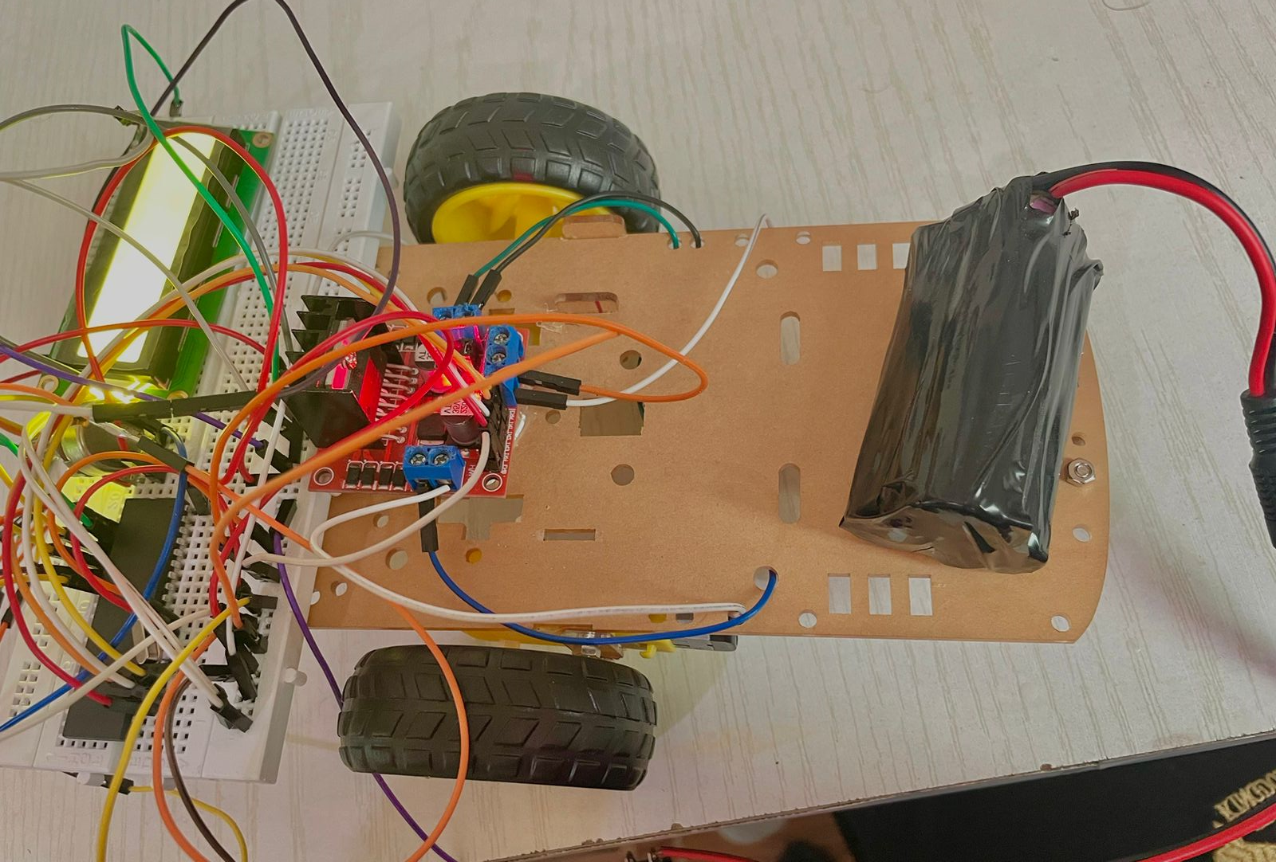

Figure 1: mechanical design

# Electrical Design

## Pic 16F877A

It is the core of radar system that the other parts connect through by programing it.

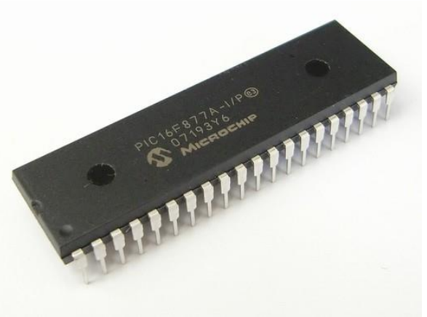

Figure 2:16F877A

The PIC16F877A is a highly recognized microcontroller widely used in the industry due to its user-friendly coding capabilities. It boasts 33 input and output pins out of a total of 40, providing ample connectivity options in this project, the PIC16F877A acts as the central processing unit, seamlessly connecting and managing all the connected sensors. To program this microcontroller, the project utilizes the Mikro C PIC compiler.

**The specifications of PIC16F877A are:**

• 8-bit RISC architecture

• 35 instruction sets

• Operating voltage: 4-5.5V

• CPU clock frequency: DC - 20 MHz

• Flash program memory: 8 KB

• RAM: 368 bytes

• EEPROM data memory: 256 bytes

• Interrupt capability: 15 sources

• Timers: 3 (8-bit, 16-bit)

• Communication interfaces: USART, SPI, and I2C

• ADC: 8-channel, 10-bit

• Digital I/O: 33

• PWM: 2

• Power-saving sleep mode

• In-Circuit Serial Programming (ICSP) capability

• 40-pin DIP package

## The IR sensor

Two IR sensors are used to determine the speed of the car between them. The major function of these IR sensors is to detect the presence or absence of the car as it passes by. By strategically placing the sensors at a certain distance apart, the time it takes for the car to travel between the sensors can be measured

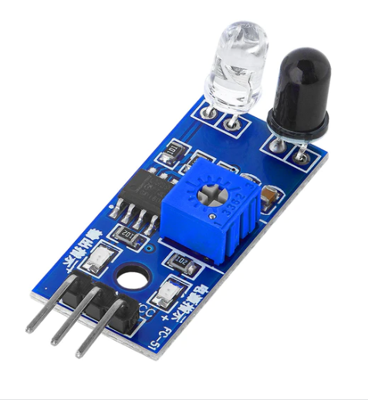

Figure 3: IR sensor

**The specifications of the IR sensor are:**

* Sensing Range: The maximum distance at which the IR sensor can detect objects. It can range from a few centimeters to several meters, depending on the sensor model.
* Output Type: IR sensors can have different types of outputs, such as analog voltage, digital signal (e.g., on/off), or serial communication (e.g., I2C or SPI).
* Detection Method: IR sensors can use various methods to detect objects, such as reflective sensing (detecting light reflected by an object), interruptive sensing (detecting interruption of the sensor's beam), or ambient light suppression (filtering out ambient light interference).
* Sensitivity: This specification indicates how well the IR sensor can detect objects at different distances or under varying lighting conditions. Higher sensitivity allows for more accurate and reliable detection.
* Response Time: The time it takes for the IR sensor to detect an object and provide an output signal. Faster response times enable real-time object detection.

## H-Bridge

An H-bridge is a circuit configuration commonly used in electronics and robotics to control the direction and speed of DC motors. It consists of four switches, typically transistors or MOSFETs, arranged in a specific pattern resembling the letter "H." By selectively turning on and off these switches in a coordinated manner, the H-bridge circuit can reverse the polarity of the voltage applied to the motor terminals, allowing for bidirectional motor control. This arrangement enables precise control over the motor's movement, including forward and reverse rotation, as well as the ability to vary the speed by adjusting the duty cycle of the applied voltage. The H-bridge configuration is widely utilized in various applications, such as robotics, automotive systems, and motorized devices, where accurate and flexible motor control is required.

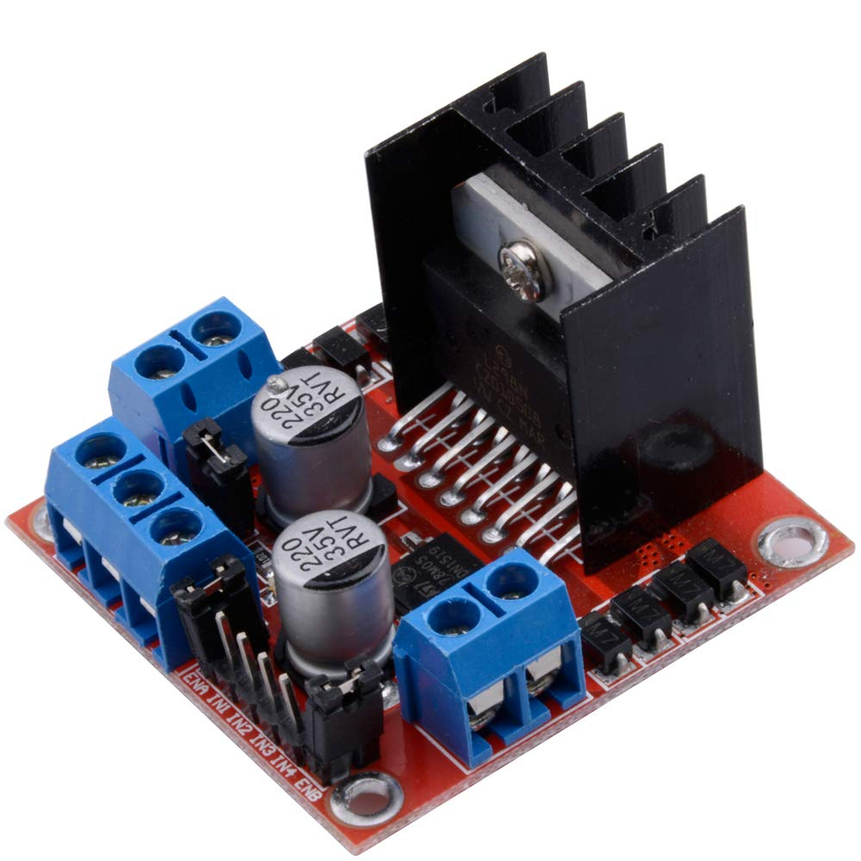

Figure 4: H-Bridge

**The specifications of the H-Bridge are:**

* Voltage Rating: The maximum voltage that the H-bridge can handle. It should be suitable for your motor's voltage requirements.
* Current Rating: The maximum current that the H-bridge can handle. It should be sufficient to handle the current drawn by your motor.
* Control Interface: The type of control interface supported by the H-bridge, such as PWM (Pulse Width Modulation) or analog input. This determines how you can interface the H-bridge with your microcontroller or embedded system.
* Motor Compatibility: Ensure that the H-bridge is compatible with the type of motor you are using (DC motor, stepper motor, etc.) and its power requirements.
* Operating Modes: Some H-bridge modules or ICs offer additional features like braking modes, coasting modes, or current limiting to protect the motor.
* Efficiency: The efficiency of the H-bridge circuit in converting electrical energy into mechanical motion. Higher efficiency is desirable to minimize power loss and maximize the motor's performance.
* Protection Features: Look for built-in protection features such as overcurrent protection, overtemperature protection, and undervoltage lockout to safeguard the H-bridge and the motor.

## LCD (1602)

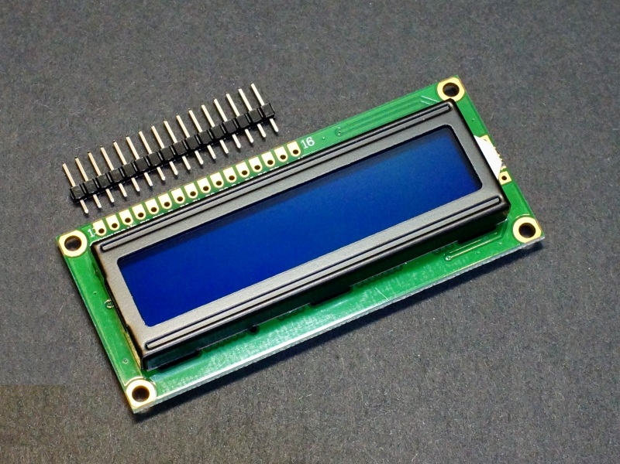

Figure 5: LCD display

An LCD, short for Liquid Crystal Display, is a widely employed type of screen for showcasing text and various forms of information. It consists of a grid-like arrangement of dots, or pixels, which can be controlled individually to form different characters and symbols. The specific type of LCD in question is referred to as 2x16, indicating that it possesses two rows and sixteen columns of characters. An LCD comprises two polarizing layers with a liquid crystal solution sandwiched in between. The liquid crystals can be manipulated to either block or permit the passage of light, thus generating the characters and symbols that appear on the screen. LCDs are commonly utilized as a user interface in embedded systems and serve as an alternative to LEDs and 7-segment displays for presenting numbers and characters. Where we used the LCD to show the speed of the car.

**The specifications of the LCD are:**

• Module size: 80.0mm(W) x 36.0mm(H) x 11.4mm(T)

• Operating temperature: -20℃ to +70℃

• Viewing angle: 12 o'clock • Power supply voltage: 5.0V DC

• Power consumption: 2.5mA (typical)

• 5x8 dots with cursor

• Built-in controller (HD44780 or equivalent)

• +5V power supply (also available for +3V) • 1/16 duty cycle

# Software Design

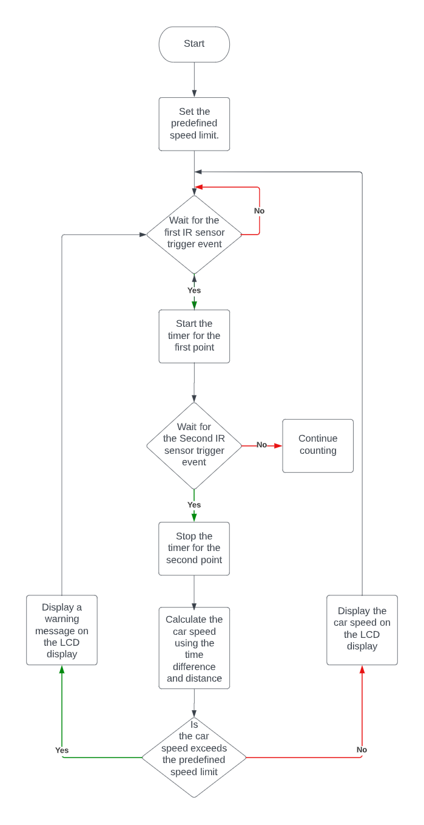

# Proteus Circuit

The software design for this project utilized mikroC, an IDE and programming language specifically designed for microcontrollers. With its C-like syntax and extensive library of pre-written functions, mikroC provided the necessary tools to interact with peripherals such as LCD displays and sensors. In our project, we utilized specific built-in libraries, including Conversions, C_String, Lcd, and Lcd_Constants, to handle sensor data and display values. The main function, executed in a continuous loop, incorporated these libraries to ensure ongoing operation as long as the system had power. Additionally, we employed the Proteus Design Suite, a versatile software for designing and simulating electronic circuits and microcontroller-based systems. Proteus allowed us to evaluate and troubleshoot our designs virtually before implementing them on real hardware, enhancing the efficiency and accuracy of our development process.

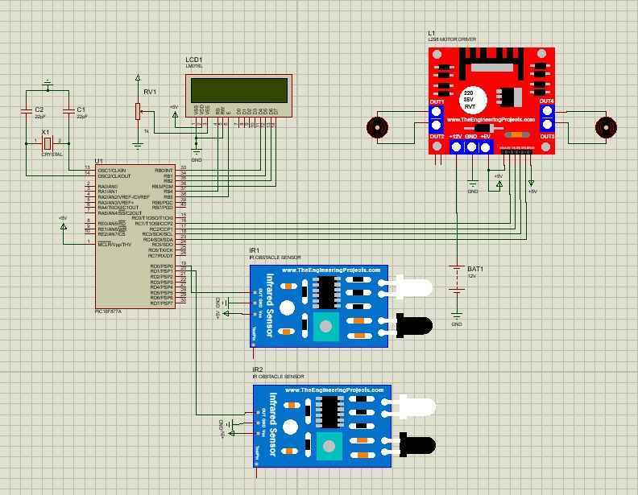

Figure 6: Proteus circuit diagram

# Problems and Recommendations

1. When we add timer code the PWM has much delay

**Solved by reducing the delay**

1. We had a problem with the relation between the speed and the timer

**Solved by modifying the equation to match the system**

1. In our proposal, we estimated that our items would cost about 38 JD

**In reality, it ended up costing us 68 JD**

# Conclusion

The primary objective of the project was to accurately detect and monitor the speed of the car in real-time, leveraging the capabilities of the embedded system.

By strategically positioning the two IR sensors, the system effectively captured the car's movement, allowing for precise measurements of the time it took for the vehicle to pass between the sensors. These measurements formed the foundation for calculating the car's speed, ensuring reliable and accurate speed tracking.

The integration of the DC motors within the kit car played a pivotal role in maintaining consistent and controlled motion throughout the speed tracking process. Through meticulous synchronization with the IR sensors, the embedded system facilitated seamless data collection, minimizing potential errors and optimizing the accuracy of the speed measurements.

The software component of the embedded system encompassed advanced algorithms and data processing techniques. It efficiently handled the sensor data, performed complex calculations, and presented the real-time speed information through an intuitive user interface. The interface not only provided a visually appealing representation of the car's speed but also ensured its comprehensibility for users of varying technical backgrounds.

The successful execution of this project demonstrates the potential and viability of embedded systems in effectively tracking and monitoring car speeds. The acquired accurate speed measurements hold considerable significance in diverse fields, including automotive research, driver safety analysis, and performance evaluation.

Overall, this project showcases a professional-grade implementation of an embedded system for car speed tracking, employing a kit car with DC motors and IR sensors. The attained results affirm the project's efficacy, emphasizing its potential for practical applications across various domains.

# References

* PIC 16F877A MCU Datasheet: <https://ww1.microchip.com/downloads/en/devicedoc/39582b.pdf>
* H-Bridge Datasheet: <https://www.sparkfun.com/datasheets/IC/SN754410.pdf>
* LCD 1602A Datasheet:

<https://datasheetspdf.com/pdf-file/519148/CA/LCD-1602A/1>